**Tour De France**

# Introduction

The Tour de France is a prestigious cycling event that began in 1903, organized by the French newspaper L'Auto to boost sales. It has a rich history of overcoming challenges, including disruptions due to World Wars, and has grown into a global tradition.

Male cyclists from around the world gather each July to compete in this grueling race, showcasing human endurance and sportsmanship. The race features multiple stages covering about 3,500 kilometers over three weeks. It is composed of individual stages that together form the larger tournament, with iconic climbs like Alpe d'Huez and international team participation adding to its appeal.

The Tour de France symbolizes endurance, teamwork, and international camaraderie, reflecting the unwavering spirit of cyclists who conquer its demanding stages.

# Aims and Objectives

The primary aim of this project is to provide individuals with a comprehensive understanding of the captivating and demanding world of the Tour de France.

By delving into the intricacies of this exhilarating game, we intend to expose a wider audience to the excitement, challenges, and unique dynamics that define the Tour de France.

Through insightful exploration and engaging content, our objective is to share the joy and intensity of this remarkable sporting event, fostering a greater appreciation for the athletes, their dedication, and the overall spirit of competition.

# Flow Process

**Data Sourcing**: The project dataset was gotten from <https://www.mavenanalytics.io/challenges/maven-tour-de-france-challenge/25?utm_source=email&utm_campaign=maventourdefrancechallenge_email_maven>

**Data Preparation**: This process entails wrangling, cleaning, and outlier removal within the dataset, coupled with exploratory data analysis (EDA) to extract significant insights. Through meticulous data preparation and filtering, anomalies are identified and addressed, enabling a refined dataset. Subsequent exploratory analysis delves into patterns, trends, and relationships, unearthing valuable information that drives informed decision-making and a deeper understanding of the data's underlying dynamics.

The analysis was executed utilizing Microsoft Excel, with visualization achieved through Microsoft Power BI.

# Findings

• Four riders share the record for the most wins with 5 victories each, but only Miguel Indurain achieved consecutive wins.

• Over the course of its history, the race has covered a total distance of 456,000 kilometers since its inception.

• The Tour de France has featured a grand total of 2189 stages since its inception.

• France boasts the highest number of victories in the race, securing the top spot with 38 wins, followed by Belgium with 18.

• The shortest winning completion time for the race is 79 hours, while the longest stands at 238 hours. These times are influenced by variations in the number of stages.

• A total of 64 different cyclists have claimed victory in the Tour de France throughout its history.

• Among the various stage types, plain stages are the most frequent, closely followed by mountain stages.

• The route from Pau to Bordeaux stands out as the most common route taken in the Tour de France.

• The number of stages in the race has evolved over time, initially starting with 6 stages and now encompassing up to 21 stages in modern editions.

# Visuals

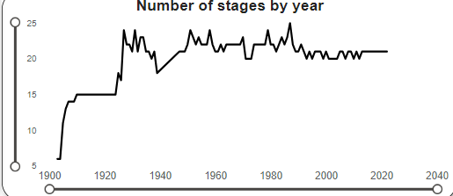

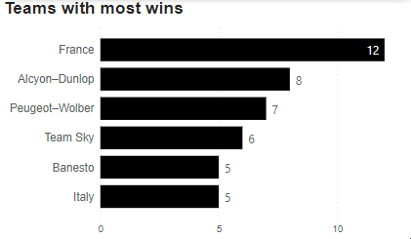

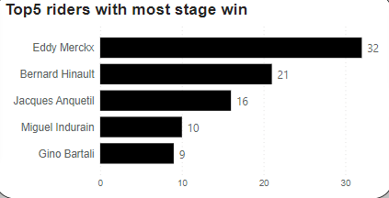

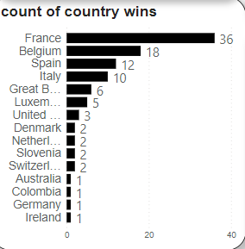

# Conclusion

The Tour de France embodies endurance, strategy, and culture. Its challenging stages, vibrant jerseys, and symbolism inspire inclusivity and excellence. Embrace its ethos, be part of a legacy that conquers challenges, and embrace diversity. The Tour weaves human stories and symbolizes determination. It holds global impact, economic influence, and sustainability, representing a unique historical significance. Amid intense racing, it adds joy, creativity, and whimsy.

The Tour de France embodies endurance, strategy, and culture. Its challenging stages, vibrant jerseys, and symbolism inspire inclusivity and excellence. Embrace its ethos, be part of a legacy that conquers challenges, and embrace diversity. The Tour weaves human stories and symbolizes determination. It holds global impact, economic influence, and sustainability, representing a unique historical significance. Amid intense racing, it adds joy, creativity, and whimsy.